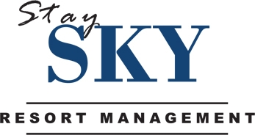

HOSPITALITY JOB FAIR /
FERIA DE EMPLEO
JOIN THE #1 HOSPITALITY TEAM IN ORLANDO!

Tuesday, January 13, 2015
3:00PM – 7:00PM

Outstanding, Motivated, Guest Service-Driven Applicants Only
Prior Hospitality Industry Experience preferred
- Front Desk Agents
- Reservation Agents
- Housekeeping Supervisors
- Housekeepers
- Room Inspector
- Social Media Administrator
- Owner Liaison Account Specialist
Lake Buena Vista Resort Village & Spa Conference Center
8113 Resort Village Drive
Orlando, FL 32821

staySky Team Members Enjoy:
Healthcare Coverage /Supplemental Insurance Coverage
Employer-paid Group Life
Company Paid Vacation /Company Paid Holidays
Training/Development Programs /Reward/Recognition Programs/ Incentive Programs
Hospitality Industry Memberships/Discounts
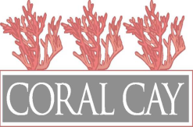
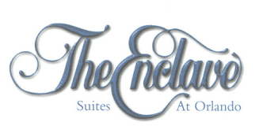
Equal Opportunity Employer

